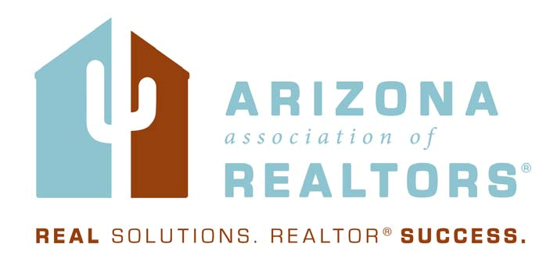

**The Strategic Plan**

**2014-2015**

Draft for Executive Committee and Board of Director Approval

**Introduction:**

The Strategic Objectives in the Arizona Association of REALTORS® (AAR) Strategic Plan are the parameters within which the Primary Committees will develop strategies to deliver programs, products, services and activities (PPSAs). Specific PPSA planning must be tested against the Association Vision, Purpose and Critical to serve Customer.

**The AAR Vision is:**

REALTOR® … the best prepared real estate practitioner with the highest standards.

**The AAR Purpose is:**

To serve its members by providing and promoting services to enhance members’ abilities to conduct their businesses with integrity and competency and to promote the extension and preservation of private property rights.

**The AAR Customer is:**

The Association has diverse customers which are the direct recipients of the Association’s PPSAs:Members in good standing and Local Associations

**Strategic Plan Development:** This plan is the result of an intensive, one and one-half day Leadership Planning Session held on April 29-30, 2013 in Prescott, Arizona. The 28 participants included AAR officers, directors, committee chairs/vice chairs, local association leaders and key AAR management personnel. The 2013-2014 Strategic Plan created a solid foundation for the 2014-2015 Plan, so that the participants needed only to concentrate on current programs and future considerations, not redrafting the entire strategic plan.

AAR President-elect Evan Fuchs facilitated the planning process. A critical first step was to ensure the participants were thoroughly familiar with the organization and the market environment in which it operates. This was accomplished through several methods:

* An overview of the Session Objectives by President-elect Evan Fuchs
* A briefing on the “state of the association” by AAR CEO Michelle Lind
* An overview of current AAR Business Plans by the 2014 Primary Committee Chairs

In addition, the participants reviewed and discussed: the Swanepoel Trends Report; the evolution of the Business Services & Technology Committee (BS&T); the 2013 Technology Presidential Advisory Group Recommendations and the BS&T Three-Year Technology Strategy recommendations. President-elect Fuchs and CEO Lind reviewed the status of the current Strategic Plan. President-elect Fuchs worked with the group to determine which areas of the current Strategic Plan required revision or additional focus. The consensus of the participants was that the top PPSAs that the Association provides for its members better than any other entity are Advocacy and Risk Management. As a result, the following Strategic Plan for 2014 was developed.

**THE STRATEGIC PLAN**

**AREA 1: GOVERNANCE AND OPERATIONS**

**Purpose:** AAR is a member driven professional organization that delivers fiscal responsibility, functions within a fluid operational structure, responsive governance model and collaboratively partners with local and the national association to anticipate and satisfy member needs.

**Strategic Objective 1.A:** AAR is an effective manager of the member’s finances

**Strategic Objective 1.B:** AAR is a member directed non-profit corporation

**Strategic Objective 1.C:** AAR runs a tight ship operationally

**Strategic Objective 1.D:** AAR is regarded as an influential voice and partner to local, state and NATIONAL ASSOCIATION OF REALTORS®

**Strategic Objective 1.E:** AAR offers a value package that helps increase the efficiency and profitability of our members

**AREA 2: GOVERNMENT AFFAIRS**

**Purpose:** AAR is the most powerful and influential political force in Arizona.

**Strategic Objective 2.A:** AAR proactively advocates and protects private property rights

**Strategic Objective 2.B:** AAR is armed with the most knowledgeable advocates

**Strategic Objective 2.B.2:** AAR cultivates strong grass roots in each local association for statewide impact

**Strategic Objective 2.C:** AAR leverages influential relationships

**Strategic Objective 2.D:** AAR inspires and capitalizes member political contributions and efforts

**AREA 3: RISK MANAGEMENT**

**Purpose:** AAR provides members with unsurpassed risk management tools.

**Strategic Objective 3.A:** AAR forms establish the standard of care in the industry

**Strategic Objective 3.B:** AAR maintains claims statistics to identify liability trends

**Strategic Objective 3.C:** AAR maintains comprehensive and accessible legal information for member use

**Strategic Objective 3.D:** AAR provides a program for early and effective claims resolution

**Strategic Objective 3.E:** AAR is proactive and progressive in how it disseminates risk management information

**Strategic Objective 3.F:** AAR promotes laws that reduce member liability

**Strategic Objective 3.G:** AAR provides timely and relevant risk management information/education

**Strategic Objective 3.H:** AAR maintains an effective Legal Hotline

**Strategic Objective 3.I:** AAR provides unsurpassed Professional Standards enforcement and an ongoing Professional Standards training program

**AREA 4: MEMBER COMMUNICATIONS AND OUTREACH**

**Purpose:** AAR communicates the right message to the right people in methods that reach out, inform and engage the membership.

**Strategic Objective 4.A:** AAR creates and maintains a consistent system of communication management (including methods of communication and options for communication delivery)

**Strategic Objective 4.B:** AAR disseminates pertinent relevant, timely industry information

**Strategic Objective 4.C:**AAR investigates and implements communication methods to increase the effectiveness of AAR’s efforts to reach out to members

**AREA 5: PROFESSIONAL & BUSINESS DEVELOPMENT**

**Purpose:** AAR delivers preeminent educational programs and resources that positions AAR members to succeed in the real estate industry.

**Strategic Objective 5.A:** AAR provides the ultimate in REALTOR® post licensing education

**Strategic Objective 5.B:** AAR evaluates the effectiveness, structure and format of the Graduate REALTOR® Institute (GRI) program and provides the resources to ensure that the program offers unsurpassed post licensing curriculum.

**Strategic Objective 5.C:** AAR utilizes the most effective education delivery

**Strategic Objective 5.D:** AAR provides a spectrum of services to brokerages/owners to enhance their business

**Strategic Objective 5.E:** AAR maintains a cadre of qualified educators in the industry

**Strategic Objective 5.F:** AAR develops subject matter assessments to ensure instructors master the subject they are teaching

**Strategic Objective 5.G:** AAR provides development opportunities/tools/programs specifically for state and local association leadership

**AREA 6: BUSINESS SERVICES**

**Purpose:** AAR supports the success of REALTOR® members with business services.

**Strategic Objective 6.A:**AAR controls the delivery of AAR forms and provides the delivery of AAR forms to members as a member benefit

**Strategic Objective 6.B:** AAR provides technology tools other than forms delivery as a member benefit only if AAR is in a unique position to provide the tool, or the tool creates value statewide, or if the tool advances the real estate industry and the AAR Vision.

**Strategic Objective 6.C:** AAR investigates and provides information on products and services that increase efficiency and profitability of member business operations

**Strategic Objective 6.D:**AAR negotiates discounts for products and services that benefit members