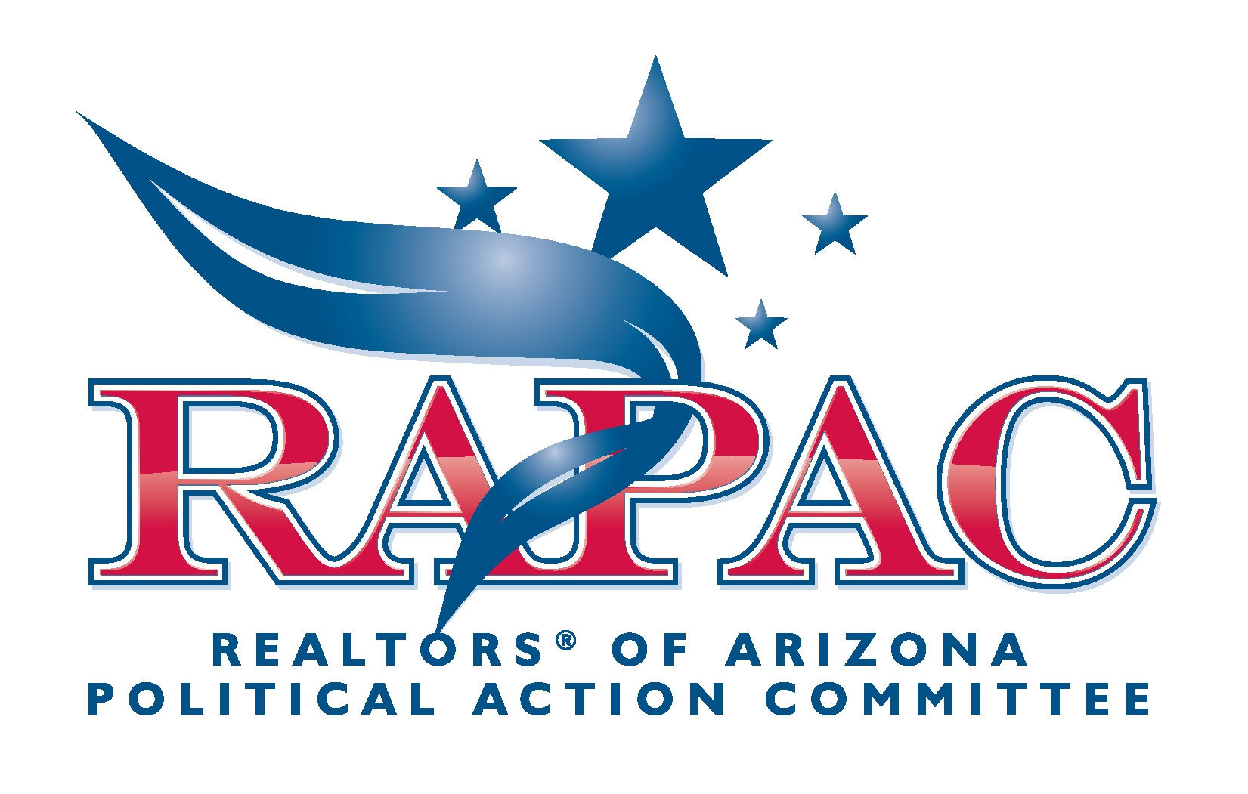
Make sure your business stays in business…
COMMIT TO RAPAC TODAY NOT TOMORROW!

What is RAPAC?
The REALTORS® of Arizona Political Action Committee (RAPAC) was formed to support our members and make sure your livelihood and your industry continues to thrive.

The mission of RAPAC is to develop and foster relationships with the Arizona Legislature, promote favorable legislation, and/or combat policy and bills with the potential to cause harm or unfair hardship for the real estate industry.

Why should I commit to RAPAC?
- RAPAC opens doors to ensure your doors stay open.
- RAPAC is a security blanket to protect you from costly, unnecessary policies and legislation - which has saved you thousands of dollars annually.
- RAPAC addresses issues of vital importance to your livelihood such as ADRE regulation, lot splits, HOAs, taxes, and property rights issues.
- Your commitment to RAPAC insures the future of our industry.

How do I commit?
Purchase a RAPAC pin. The annual RAPAC Pin program is the primary fundraiser for RAPAC's political activities. These pins prominently display your commitment to RAPAC. We offer five levels that make it easy for you to invest in your future. We recommend the following:

- Golden R Pin- $5,000 or greater commitment- Great for broker/owners or anyone who values the importance of political action! Signifies the highest level of commitment.
- Crystal R Pin - $2,500 to $4,999- An outstanding way for brokers, owners and REALTOR® members to support the industry that gives them so much business.
- Sterling R Pin - $1,000 to $2,499- Again, perfect for brokers, owners and REALTOR® members by demonstrating your commitment to your livelihood.
- $500 Pin - $500-$999 – Great way for long time agents to show their dedication to their industry.
- $250 Pin - $250-$499 – Show others your support of your industry and your support of political action.
- $99 Pin - $99-$249 – This is the perfect way for office staff and new REALTOR® members getting started in the business. Represents your newfound commitment to your profession and its future.

Wear it proudly.
Be proud of your commitment. At RAPAC functions, for business calls or around the office -- wherever you are -- wear your PRAAC pin with pride!

