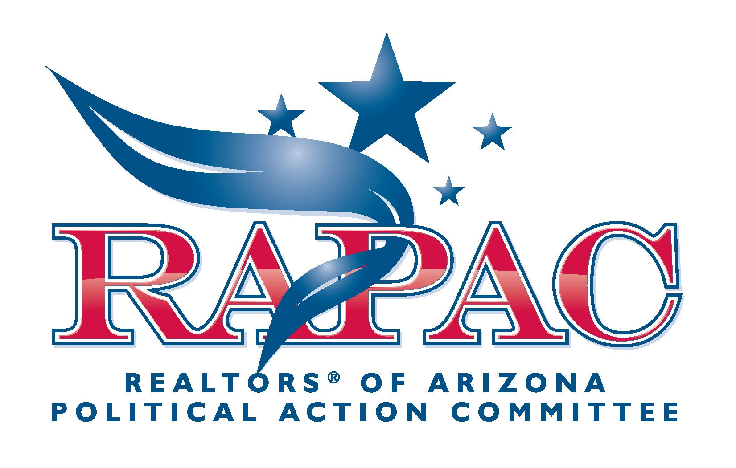
Local PAC Fundraising Alternatives

There may be times when your association feels it is necessary or needs to raise additional funds, over and above the RAPAC dues billing process. In these instances, you may consider sponsoring some type of fundraising event. A word of caution: Larger, more complicated events do not necessarily yield more proceeds.

The following is a list of various fundraising events that associations have sponsored to raise funds for RAPAC. The events can be classified into 3 categories based upon the level of association staff time needed to administer each:

(1) intensive, (2) moderate, and (3) minimal.
Intensive: Includes auctions, raffles and Monte Carlo (mock gambling) fundraising events.
Moderate: Includes dinners, receptions, dances, cruises, etc.
Minimal: Include association membership meeting 50/50 raffles ($1 or $2 contributions.)

All activity (receipts and disbursements) related to the event is required to be reported to
the appropriate state and federal elections agencies. Therefore, please contact AAR staff
in advance if you are conducting any type of RAPAC fundraising event in order to gain
a thorough understanding of the administrative and reporting requirements. Please contact Megan Cummings at (602) 248-7787 or by email: megancummings@aaronline.com.

Details for Hosting a RAPAC Event
This has been prepared to assist with the details in planning a RAPAC event.

Things to Do:
- Schedule Event – date and time - decide on event location, theme, type, entertainment and menu
- Establish host committee to help with event preparation, planning and fundraising
- Arrange for food and drink according to menu
- Arrange for entertainment, if required
- Obtain VIP (Legislator/Event Speaker) confirmation before mailing invitations/fliers
- Prepare and mail invitation or flier with event information (Example attached)
- Follow-up with host committee and provide encouragement to sell additional tickets
- Decorate event location as you deem appropriate
- Provide table and chairs for registering guests and collecting contributions
- Post signs at major corner directing invitees to event (if appropriate) – take down after event
- Obtain address, occupation and employer of all contributors for thank you's and also for political reporting requirements
- Send thank you's to event hosts, contributors and attendees
- Provide membership and contribution forms for event
- Provide RAPAC information

***SAMPLE Invitation***
Please join friends, family, co-workers and
the ___________ ASSOCIATION OF REALTORS® members
in a celebration of REALTORS® success in politics
Contributions to support our Political Action Committee-RAPAC

Please join us at this important event. One of the most vital services organized real estate provides is representation in the halls of government. Your RAPAC contribution goes to local, state and federal candidates who support your industry’s position on issues important to REALTORS®.

Please do your part to support the REALTOR®!

Date: Thursday, August 22, 2010
Time: 5:30 p.m to 7:30 p.m.
Address: 2370 Harmon Way
City, AZ 55555
Directions: I-80 to Jefferson Blvd. Exit
West on Jefferson
North on Harmon.
Donation: $99 per person or FREE if you have already made your $99 contribution to RAPAC
Please make checks payable to: RAPAC
For more information, contact [Name of Host/Hostess] at (122) 333-4444
Please complete form below and mail to: ARIZONA ASSOCIATION OF REALTORS®
255 E. Osborn Rd. #200
Phoenix, AZ 85015
-------------------------------------------------------------------------------------------------------------------------
􀂅 Yes, I will attend and have already contributed $99.
􀂅 Yes, I will attend and have included my donation of $________.
􀂅 No, I cannot attend, but I am including my donation of $________.
Name: Business Name:
Address:
City, State, Zip
Phone number

**Contributions are not tax deductible for federal or state income tax purposes.**

