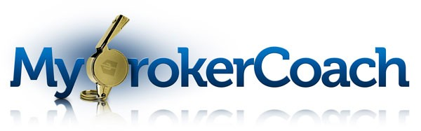

**Thinking about becoming a Broker? Manager? Opening your own office?**

**Working from home as a self employed Broker ?**

**Just want to enhance your knowledge and improve your skills?**

**We have a great opportunity for you!**

**MODULE 100 – MY BROKER COACH**

This module helps you understand the systems you will need to put in place, including business planning, budget development and profitability, policies and procedures, forms, file systems, office management, technology, staffing, business models, types of insurance needed, and ADRE requirements and rules.

***ONLY $49.00 FOR THE ENTIRE MODULE!***

**Chapter 1 – Setting Up Your Company**



**Chapter 2 – Business Planning**

**Chapter 3 – Budgeting**

**Chapter 4 – Developing Policies**

**Chapter 5 – E & O Insurance**

My Broker Coach is a blended learning environment for brokers who want to hone their skills and knowledge and this program is designed to fill that gap. It consists of online education segments, homework assignments/activities and individual coaches/mentors assigned to each chapter to give you tips and feedback. Each segment is 30 to 40 minutes (home work will take a little extra time) completed at your own pace and when you have time.

Log into:

<https://www.lectlearn.com/products/lectlearn/registration/2/menu_group.aspx?o=0804>

Contact: [Laurakovacs@aaronline.com](mailto:Laurakovacs@aaronline.com) if you prefer an email link

Brought to you by the:



Arizona Association of REALTORS® **602-248-7787**